gpuCloth ReadMe
Min Tang (tang_m@zju.edu.cn), 2018-06-26

Introduction
gpuCloth is a GPU-based cloth simulation system developed by Dr. Min Tang and Prof. Dinesh Manocha, based on their research results:
- Min Tang, Zhongyuan Liu, Roufeng Tong, and Dinesh Manocha, PSCC: Parallel Self-Collision Culling with Spatial Hashing on GPUs, Proceedings of the ACM on Computer Graphics and Interactive Techniques, 1(1), 18:1-18, 2018.
- Tongtong Wang, Zhihua Liu, Min Tang, Roufeng Tong, and Dinesh Manocha, Efficient and Reliable Self-Collision Culling using Unprojected Normal Cones, Computer Graphics Forum, 36(8), 487-498, 2017.
- Min Tang, Huamin Wang, Le Tang, Ruofeng Tong, Dinesh Manocha, CAMA: Contact-Aware Matrix Assembly with Unified Collision Handling for GPU-based Cloth Simulation, Computer Graphics Forum, 35(2): 511–521, (Proceedings of Eurographics 2016), 2016.
- Zhendong Wang, Min Tang, Ruofeng Tong, Dinesh Manocha, TightCCD: Efficient and Robust Continuous Collision Detection using Tight Error Bounds, Computer Graphics Forum, 34(7): 289-298, (Proc. of Pacific Graphics), 2015.
- Min Tang, Ruofeng Tong, Zhendong Wang, Dinesh Manocha, Fast and Exact Continuous Collision Detection with Bernstein Sign Classification, ACM Transactions on Graphics, 33(6), Article 186 (November 2014), 8 pages (Proc. of ACM SIGGRAPH Asia), 2014.
- Min Tang, Ruofeng Tong, Rahul Narain, Chang Meng, and Dinesh Manocha, A GPU-based Streaming Algorithm for High-Resolution Cloth Simulation, Computer Graphics Forum, 32(7): 21–30, (Proceedings of Pacific Graphics 2013), 2013.

gpuCloth uses FEM-based time integration and continuous collision handling techniques, and run the whole simulation pipeline on GPU. These techniques make it both robust and efficient for high-resolution cloth simulation.

gpuCloth is developed on Windows 7 platform with Microsoft Visual Studio 2013 and CUDA 9.1. It has also been ported to Ubuntu+gcc environment.

Build and Run It
Before compile gpuCloth, you first need compile the JASON library, its solution file is at \gpuCloth\jsoncpp\makefiles\vs71, open jsoncpp.sln, build json_libmt.lib/ json_libmtd.lib, and put them at \gpuCloth\lib.

Open the gpuCloth.sln with Microsoft Visual Studio 2013, and compile it.

There are 4 different configurations:
Debug/Release | Standalone version
Debug-interface/Release-interface | Interface version

Standalone vs. Interface
The standalone version provides all the details, and demonstrate the pipeline of simulation.
The interface version is an interface that other applications can be easily integrated with our simulator.

After build the standalone version (Debug/Release), you can run it with following parameters:
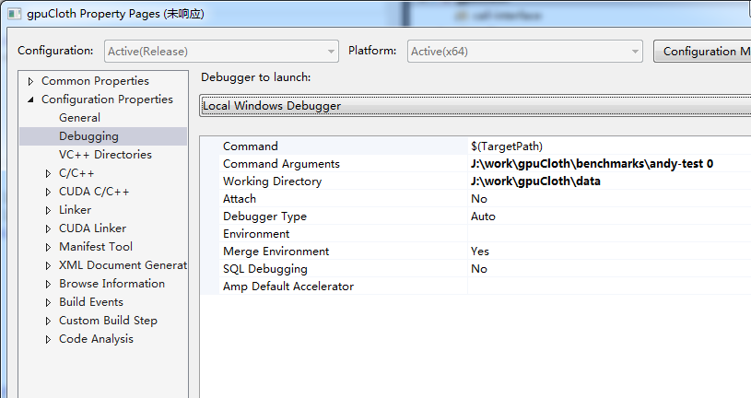
You will see:
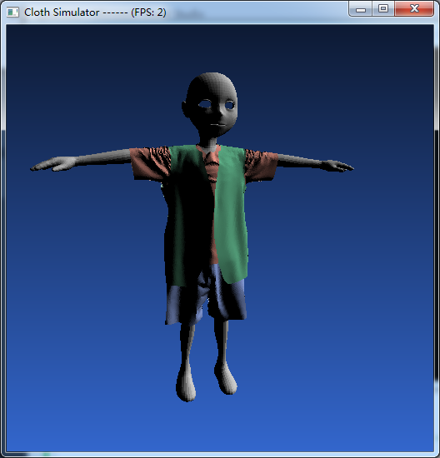

Another benchmark:
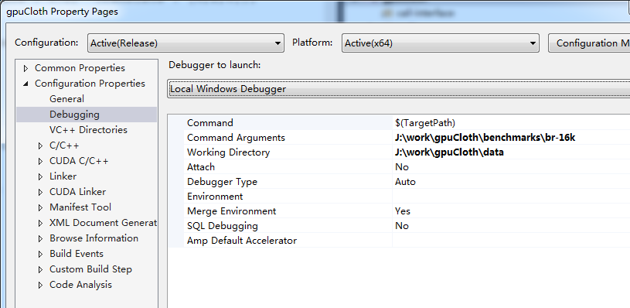
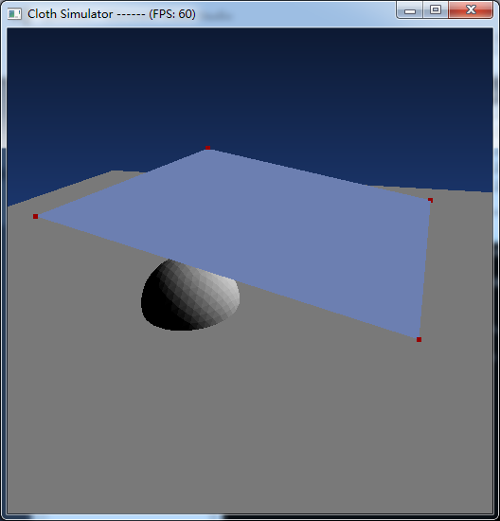 | 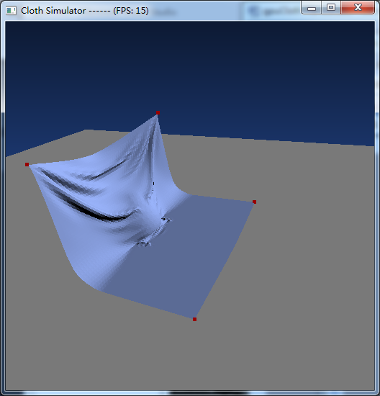

After build the interface version (Debug-interface/Release-interface), you can run it with following parameters:

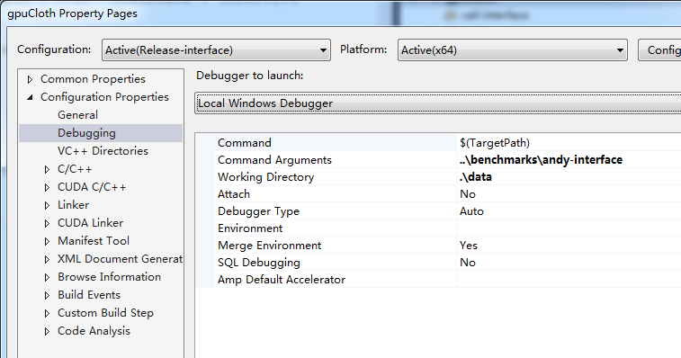
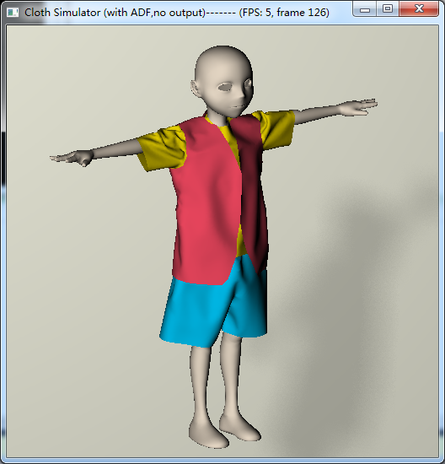

run with parameters:
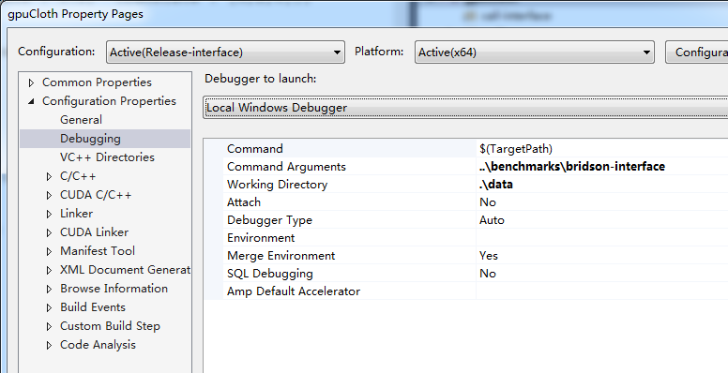
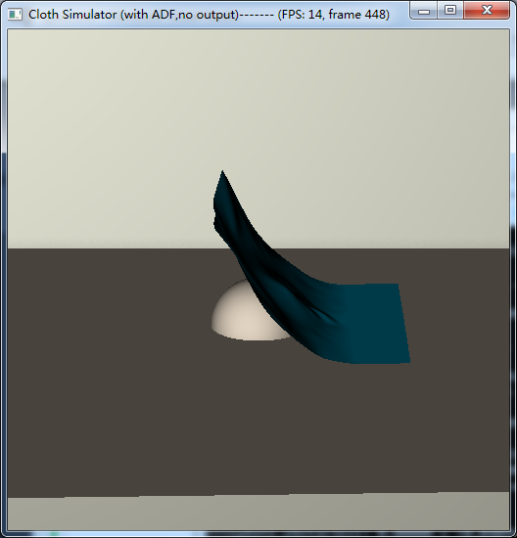

Mouse/Keyboard Control
- Keys:
ESC/'q' | Quit the program
's' | Run a step
'd' | Run/Pause
'o' | Output obj files
- Mouse
Left-button | Rotate
Ctrl+Left-button | Zoom In/Out
Shift+Left-button | Pan
Right-button | Pop-up Menu

File list
- Files and directory at /
File/Directory | Description
gpuCloth.sln | The solution file for Microsoft Visual Studio 2013
gpuCloth.vcxproj | VC++ project file
alglib/ | ALGLIB - External library for nonlinear optimization on CPU
jsoncpp/ | JSON - External library for jason file parser
eigen/ | Eigen - Extern library for linear system solver on CPU
inc/ | Eternal header files (OpenGL related)
lib/ | External library files (CUDA utility , glut, glew, and json)
cuda/ | GPU files for cloth simulation
spatial-hashing/ | GPU files for spatial hashing
src/ | Utility and tools for the simulation pipeline
interface/ | An interface to call all the simulation functions
data/ | Material and Mesh files for benchmarks
benchmarks/ | Benchmarks for demonstration

- Files in /cuda
File/Directory | Description
box.cuh | Bounding volume definition
constraint.cuh | Various constraints
cudaCG.cpp | Conjunctive Gradient Solver
def.cuh | Useful definitions
dnf-filter.cuh | Non-penetration Filter
mat3.cuh | Matrix 3x3
mat9.cuh | Matrix 9x9
matrix_builder.cuh | Dynamic Matrix Assembly
pair.cuh | VF/EE or triangle pairs
simulation.cu | GPU-based cloth simulation
tools.cu | Tool functions
tri3f.cu | Triangle IDs
vec3.cu | Vector 3D

- Files in /interface
File/Directory | Description
CCSManager.cpp | Interface Definition
CCSManager.h | Interface Definition
forceline.h | FORCEINLINE
initModel.cpp | Initialization
main.cpp | Entry point
real.h | Float/double selection
vec3f.h | Vector 3D

- Files in /spatial-hashing
File/Directory | Description
CollisionPair.h | Collect collision pairs with spatial hashing
CudaBasic.cuh | Useful functions
SH-combine.cu | Spatial Hashing Functions
SpatialHashCD.h | Spatial Hashing Functions
SpatialHashHelper.cu | Spatial Hashing Functions
SpatialHashHelper.cuh | Spatial Hashing Functions

- Files in /src
File/Directory | Description
auglag.cpp | Augmented Lagrangian Method
auglag.hpp | Augmented Lagrangian Method
blockvectors.hpp | Sparse Matrix
cloth.cpp | Cloth Class Definition
cloth.hpp | Cloth Class Definition
collision.cpp | Collision Response
collision.hpp | Collision Response
conf.cpp | Configuration File Parser
conf.hpp | Configuration File Parser
constraint.cpp | Various Constraints
constraint.hpp | Various Constraints
dde.cpp | Material Loader/Evaluator
dde.hpp | Material Loader/Evaluator
eigen.cpp | Linear System Solver
eigen.hpp | Linear System Solver
geometry.cpp | Useful Geometry Functions
geometry.hpp | Useful Geometry Functions
gpu.cpp | GPU simulation pipeline
handle.cpp | Handles Definitions
handle.hpp | Handles Definitions
init.cpp | Initialization
io.cpp | File I/O
io.hpp | File I/O
magic.cpp | User-defined Magic Parameters
magic.hpp | User-defined Magic Parameters
main.cpp | Entry File
mesh.cpp | Mesh Class Definition
mesh.hpp | Mesh Class Definition
morph.hpp | Animation
mot_parser.cpp | Motion File Parser
mot_parser.hpp | Motion File Parser
obstacle.cpp | Obstacle Class Definition
obstacle.hpp | Obstacle Class Definition
optimization.hpp | Class Definition for Optimization
real.hpp | Float/double Selection
save.cpp | File Saver
save.hpp | File Saver
simulation.cpp | Simulation Pipeline
simulation.hpp | Simulation Pipeline
sparse.hpp | Sparse Matrix
spline.cpp | Spline Interpolation Definition
spline.hpp | Spline Interpolation Definition
timer.cpp | Timer for counting
timer.hpp | Timer for counting
transformation.cpp | Transformation Definition
transformation.hpp | Transformation Definition
util.cpp | Useful utility functions
util.hpp | Useful utility functions
vectors.cpp | Vector Class Definition
vectors.hpp | Vector Class Definition
winport.hpp | Win32 definitions

